**LAB 5&6 – REQUIREMENT SPECIFICATION**

# Use Case Diagram

Ảnh có chứa văn bản, biểu đồ, hàng, ảnh chụp màn hình

Nội dung do AI tạo ra có thể không chính xác.

# Use Case Description

A use case specification represents the sequence of events along with other information that relates to this use case.

A typical use case specification template includes the following information:

* **Title**: Title: of the use case
* **Identifier**:A unique identifier for this use case
* **User Story:** a documented description of a software feature seen from the end-user perspective.
* **Input/ Output:** Input and possible outputs of this use case
* **Preconditions:** list the state(s) the system can be before this use case starts
* **Basic course:** Describe the normal processing path
* **Alternative course**: Description of the alternative course
* **Postconditions:** list the state(s) the system can be before this use case ends

## UC1: Login

* **Title:** Login
* **Identifier:** UC1
* **Input/Output:**  
  - Input: Username, Password  
  - Output: Homepage [successful] or error message [failed]
* **Preconditions:**  
  User has an account.
* **Basic Course:**

|  |  |
| --- | --- |
| Actor (User) | System |
| 1. Open login page | 1.1 Display login page |
| 2. Enter username and password |  |
| 3. Submit form | 3.1 Validate credentials 3.2 If valid, redirect to homepage 3.3 Else, show error |

* **Alternative Course:**  
  Wrong credentials will show an error.
* **Postconditions:**  
  User session started if successful.
* **User Story:** As a user, I want to log in to CatWave so that I can access my music and playlists.

## UC2: Register

* **Title:** Register
* **Identifier:** UC2
* **Input/Output:**  
  - Input: Username, Password, Email  
  - Output: Go to homepage [successful] or request register again [failed]
* **Preconditions:**  
  User not registered yet.
* **Basic Course:**

|  |  |
| --- | --- |
| Actor (User) | System |
| 1. Open register page | 1.1 Display register form |
| 2. Fill username, password, email |  |
| 3. Submit | 3.1 Validate data 3.2 Create account or show error |

* **Alternative Course:**  
  Username/email already taken shows error.
* **Postconditions:**  
  New account created.
* **User Story:** As a new user, I want to register an account to access features.

## UC3: Search Music

* **Title:** Search Music
* **Identifier:** UC3
* **Input/Output:**  
  - Input: Search keywords  
  - Output: Matching results [successful] or return “no songs match keywords search” [failed]
* **Preconditions:**  
  User logged in.
* **Basic Course:**

|  |  |
| --- | --- |
| Actor (User) | System |
| 1. Enter search term |  |
| 2. Click search | 2.1 Query database 2.2 Display results |

* **Alternative Course:**  
  No matching result shows 'No result found'.
* **Postconditions:**  
  Results shown.
* **User Story:** As a user, I want to search for songs, albums, or playlists easily.

## UC4: Select Playlist/Album

* **Title:** Select Playlist/Album
* **Identifier:** UC4
* **Input/Output:**  
  - Input: Selected item  
  - Output: List of songs [successful] or return “Album/playlist it not available” [failed]
* **Preconditions:**  
  Playlists/albums available.
* **Basic Course:**

|  |  |
| --- | --- |
| Actor (User) | System |
| 1. Click playlist or album | 1.1 Load and display items |

* **Alternative Course:**  
  If missing, show error.
* **Postconditions:**  
  Content displayed.
* **User Story:** As a user, I want to select a playlist or album to browse music.

## UC5: Play Song

* **Title:** Play Song
* **Identifier:** UC5
* **Input/Output:**  
  - Input: Selected song  
  - Output: Audio playback [successful] or nothing play [failed]
* **Preconditions:**  
  Song available.
* **Basic Course:**

|  |  |
| --- | --- |
| Actor (User) | System |
| 1. Select song | 1.1 Load song |
| 2. Click play | 2.1 Stream and play |

* **Alternative Course:**  
  If missing, error displayed.
* **Postconditions:**  
  Song is playing.
* **User Story:** As a user, I want to play a selected song.

## UC6: Stop Song

* **Title:** Stop Song
* **Identifier:** UC6
* **Input/Output:**  
  - Input: Stop button  
  - Output: Playback stops [successful] or continue playing [failed]
* **Preconditions:**A song is playing.
* **Basic Course:**

|  |  |
| --- | --- |
| Actor (User) | System |
| 1. Click stop | 1.1 Stop playback |

* **Alternative Course:**  
  None.
* **Postconditions:**  
  No song playing.
* **User Story:** As a user, I want to stop the current song.

## UC7: Select Song

* **Title:** Select Song
* **Identifier:** UC7
* **Input/Output:**  
  - Input: Song selection  
  - Output: Song details [successful] or nothing happens [failed]
* **Preconditions:**  
  Songs listed.
* **Basic Course:**

|  |  |
| --- | --- |
| Actor (User) | System |
| 1. Browse and select song | 1.1 Show song info |

* **Alternative Course:**  
  If not available, show error.
* **Postconditions:**Song info displayed.
* **User Story:** As a user, I want to select a song to view its information or play it.

## UC8: Create Playlist

* **Title:** Create Playlist
* **Identifier:** UC8
* **Input/Output:**  
  - Input: Playlist name  
  - Output: New playlist [successful] or return “Can not create playlist now, please try again later” [failed]
* **Preconditions:**User logged in.
* **Basic Course:**

|  |  |
| --- | --- |
| Actor (User) | System |
| 1. Click 'Create Playlist' | 1.1 Show creation form |
| 2. Enter name |  |
| 3. Confirm creation | 3.1 Save playlist |

* **Alternative Course:**  
  If name taken, show error.
* **Postconditions:**  
  Playlist created.
* **User Story:** As a user, I want to create my own playlists.

## UC9: Manage Profile

* **Title:** Manage Profile
* **Identifier:** UC9
* **Input/Output:**  
  - Input: New profile data  
  - Output: Updated profile [successful] or return “Update failed, try again later” [failed]
* **Preconditions:**  
  User logged in.
* **Basic Course:**

|  |  |
| --- | --- |
| Actor (User) | System |
| 1. Open profile settings | 1.1 Show current info |
| 2. Edit fields |  |
| 3. Save changes | 3.1 Validate and update |

* **Alternative Course:**  
  Invalid input causes error.
* **Postconditions:**  
  Profile updated.
* **User Story:** As a user, I want to update my profile information.

## UC10: Subscription

* **Title:** Subscription
* **Identifier:** UC10
* **Input/Output:**  
  - Input: Subscription choice  
  - Output: Payment page [successful] or return “subscription payment error, try again later” [failed]
* **Preconditions:**  
  User logged in.
* **Basic Course:**

|  |  |
| --- | --- |
| Actor (User) | System |
| 1. Select a subscription | 1.1 Redirect to payment gateway |

* **Alternative Course:**  
  Payment failed leads to no activation.
* **Postconditions:**  
  Subscription active.
* **User Story:** As a user, I want to subscribe for premium access.

## UC11: Payment

* **Title:** Payment
* **Identifier:** UC11
* **Input/Output:**- Input: Payment details  
  - Output: Confirmation [successful] or return “Payment error, try again later” [failed]
* **Preconditions:**  
  User in payment process.
* **Basic Course:**

|  |  |
| --- | --- |
| Actor (User) | System |
| 1. Input payment details | 1.1 Validate and process |
| 2. Confirm | 2.1 Payment success or failure |

* **Alternative Course:**  
  Payment fail shows error.
* **Postconditions:**  
  Subscription activated on success.
* **User Story:** As a user, I want to complete payment securely.

# Entity Relationship Diagram

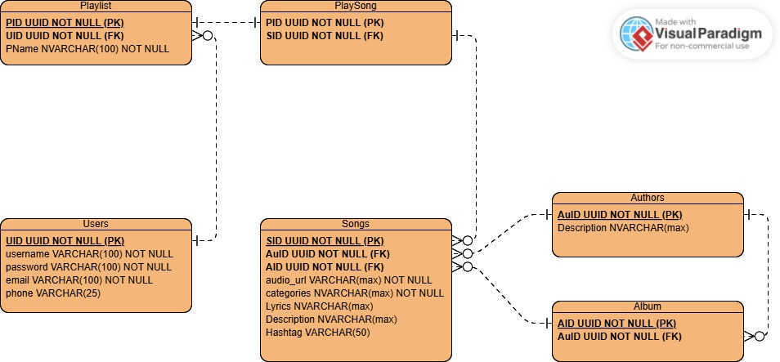

# Class Diagram

Class diagrams are used when developing an object-oriented system model to show the classes in a system and the associations between these classes. An association is a link between classes that indicates that there is a relationship between these classes.

